Duration: 2 hrs (Marriage Booking System)
ABC is a marriage booking system. We need to implement the following methods for the smooth operation of the same.
Define the classes as shown in the below class diagram, specifying all the getters and setters for
each class.

The MarriageBookingSystem(MBS) should be defined as public class, it should contain a list of available Applicants (applicantList) .

It also has the following behaviors:

- boolean addApplicant (Applicant a) This behavior accepts a Applicant as input, adds it to the list of Applicants maintained in MBS. It will return true upon the successful adding of applicant tot the system, otherwise return false.
- List<Applicant> findMatch(Applicant a) ApplicantNotFoundThis behavior accepts a applicant object and search in the applicant list maintained in the MBS and return the list of matching applicants. The criteria for matching;
- The sex should be opposite to the applicant.
- Age should be greater than or equal to the applicant.
If there is no matching found then a custom exception ApplicantNotFound needs to throw

- boolean assignApplicant(int applicantId, Applicant a) This behavior accepts an applicantId and Applicant object. Search the applicantId in the applicant list maintained in the MBS and set the partner object with passing Applicant object for that applicantId.

- boolean dropPraposal(int applicantId) This behaviour accepts an applicantId and search the applicantId in the applicant list maintained in the MBS. Then cancel the prposal for that applicant by setting the partner object as null.

- Map<Sting, Integer> findApplicantSummary() This behaviour search the applicants in the MBS, then prepare the summary of gender wise applicants who are still single (that is not allocated yet.)

NOTE: Create the tester class using Junit for all the service methods.

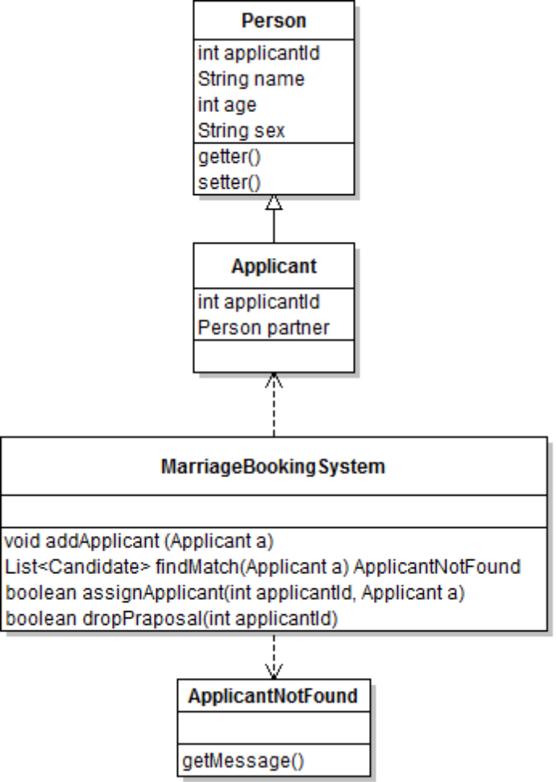

Zip Procedure:

1. In eclipse right click on your project.

2. Select copy, then on desktop paste it.

3. Now, on desktop your project folder will be available. Right click that folder and select, send to -> compressed folder.

4. Now you can find compressed file (zip) of your project folder.

